**BADU seminars & Final conference in Latvia**

During the last 6 months Zemgale NGO Centre has been spreading information about BADU project and its results in schools, universities, seminars and other events. Final event - BADU conference in Latvia took place in Jelgava Latvia March 28 in 2019.

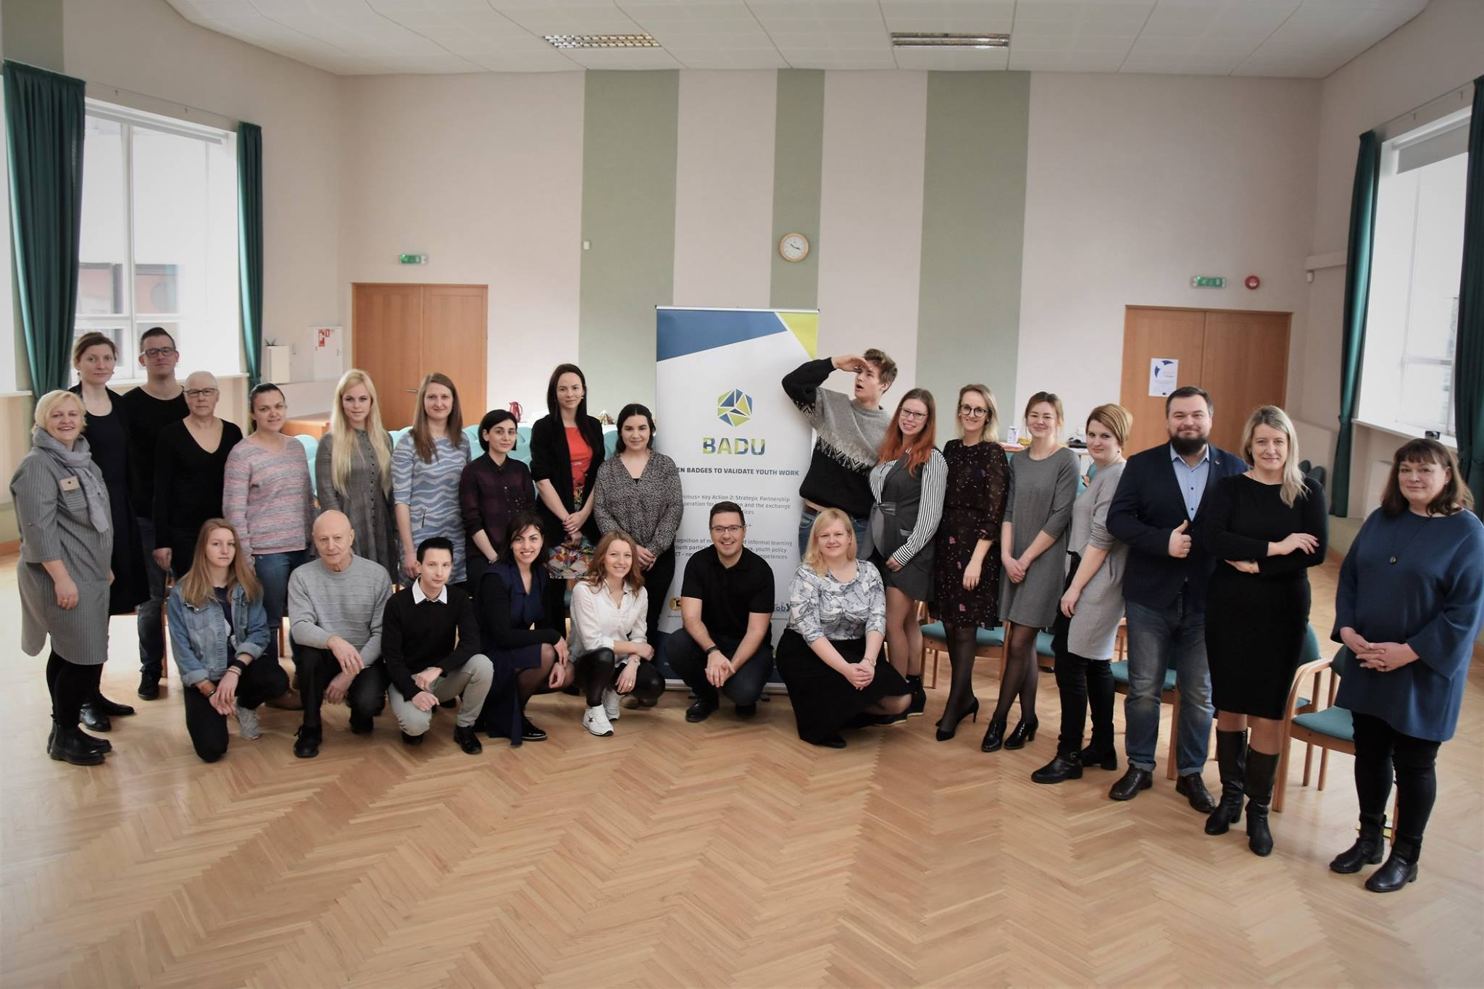

Event was lead by Zemgale NGO Centre expert Rasma Pipike and main focus was to involve youth coordinators from Zemgale region as well as active youngsters - to inform & promote BADU digital badges.

In the picture above there are youth workers of Jelgava city, Jelgava county, Dobele, Bauska counties as well as Ozolnieki county. In the second part of the conference youngsters were invited to try how the BADGES work and also to see the results of the project.

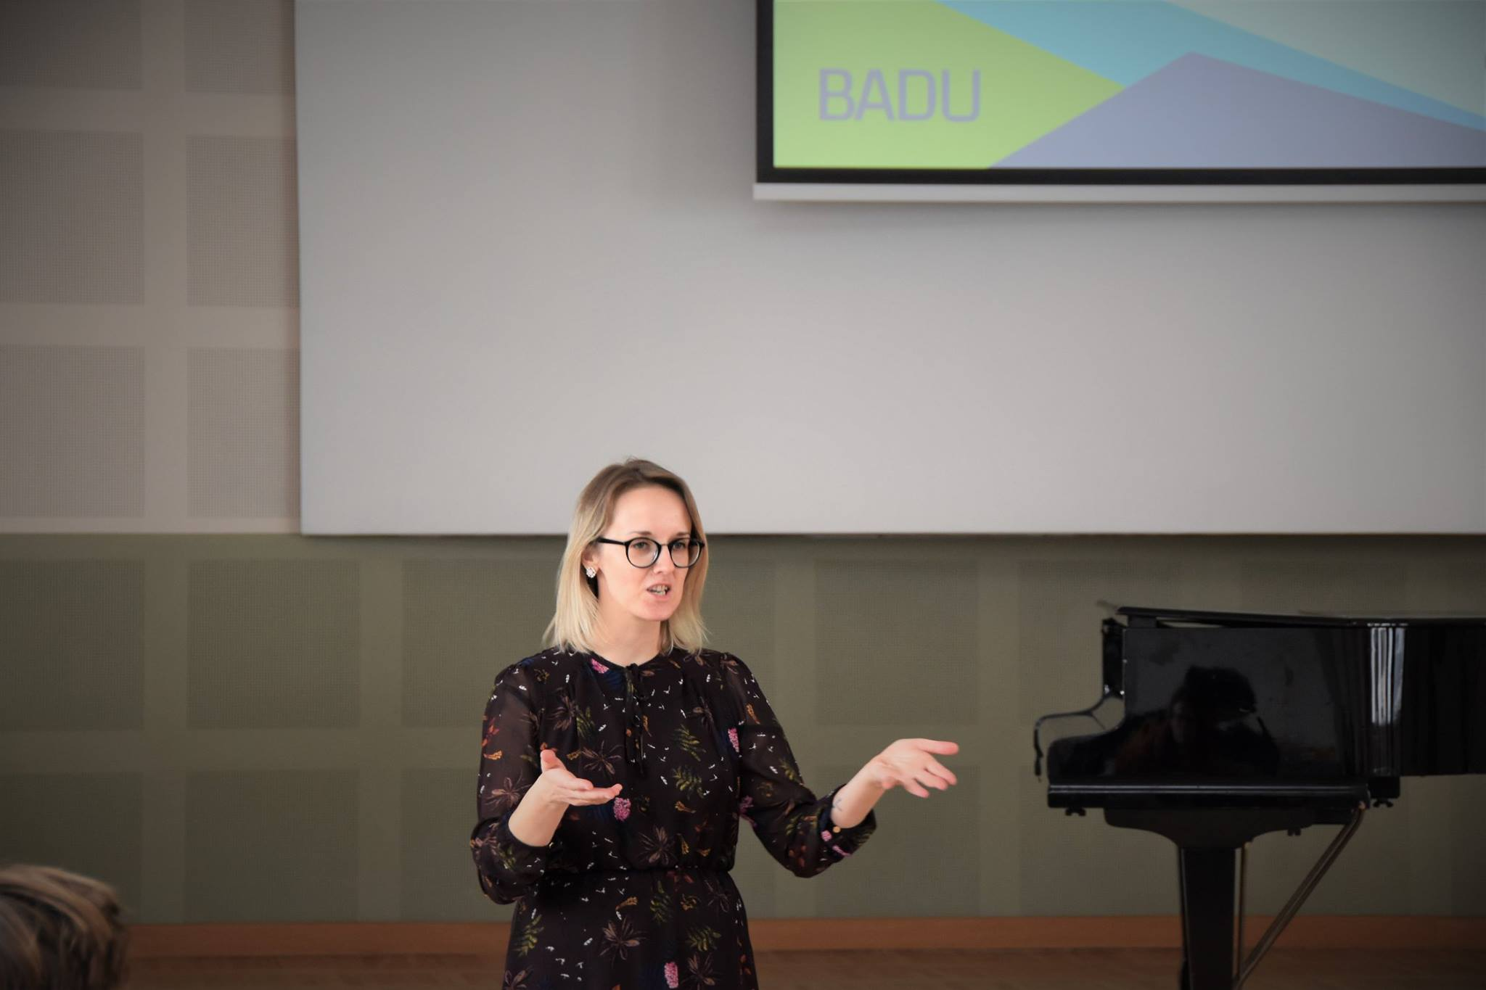

Jelgava county Youth affairs coordinator Kristine Kode informs about Jelgava county youth work and the ways how BADU badges can be used in youth work.

Other events organized in Latvia, Zemgale region:

**1st WORKSHOP** in Zemgale NGO Forum 10/08/2018

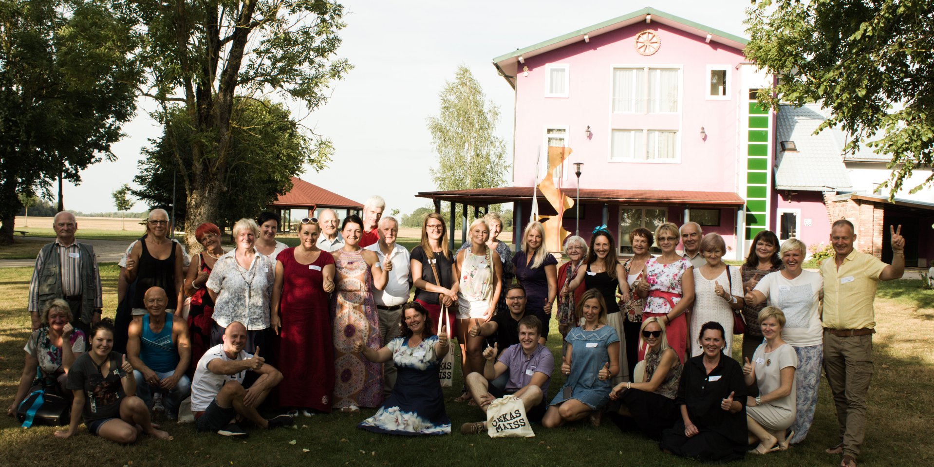

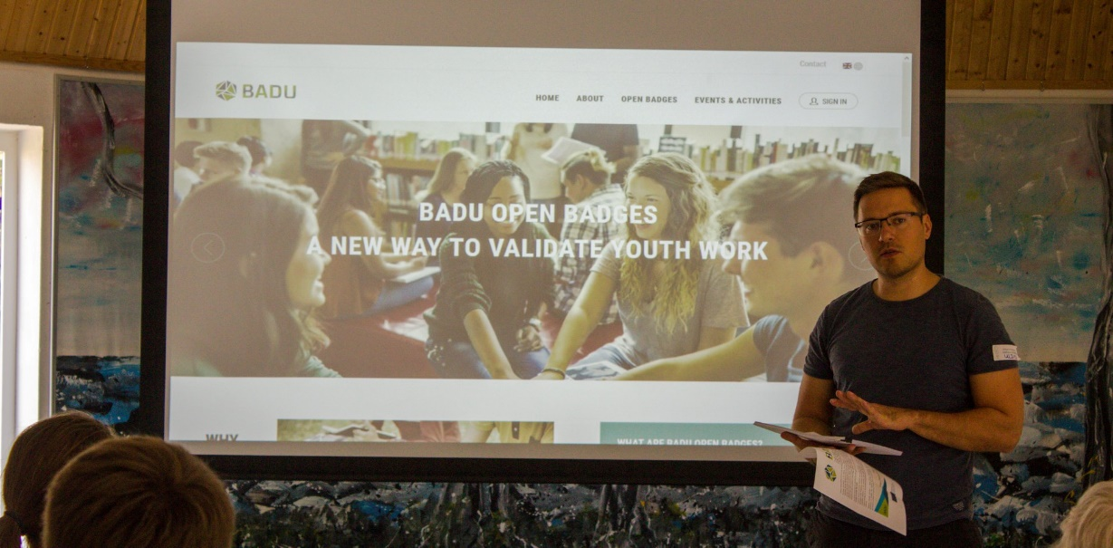

Please see more: https://www.facebook.com/pg/zemgalei/photos/?tab=album&album_id=1793803090673744

**2nd WORKSHOP** - Jelgava County 29/01/2019

Event gathered youth workers and youth leaders in order to inform abot project, to learn step by step using BADU open badges. Event organized in cooperation with Jelgava county council.

**3rd WORKSHOP** - Jelgava secondary school of Technologies, 04/02/2019

Event was organized to inform teachers & youngsters about the project and to try out how the system works.

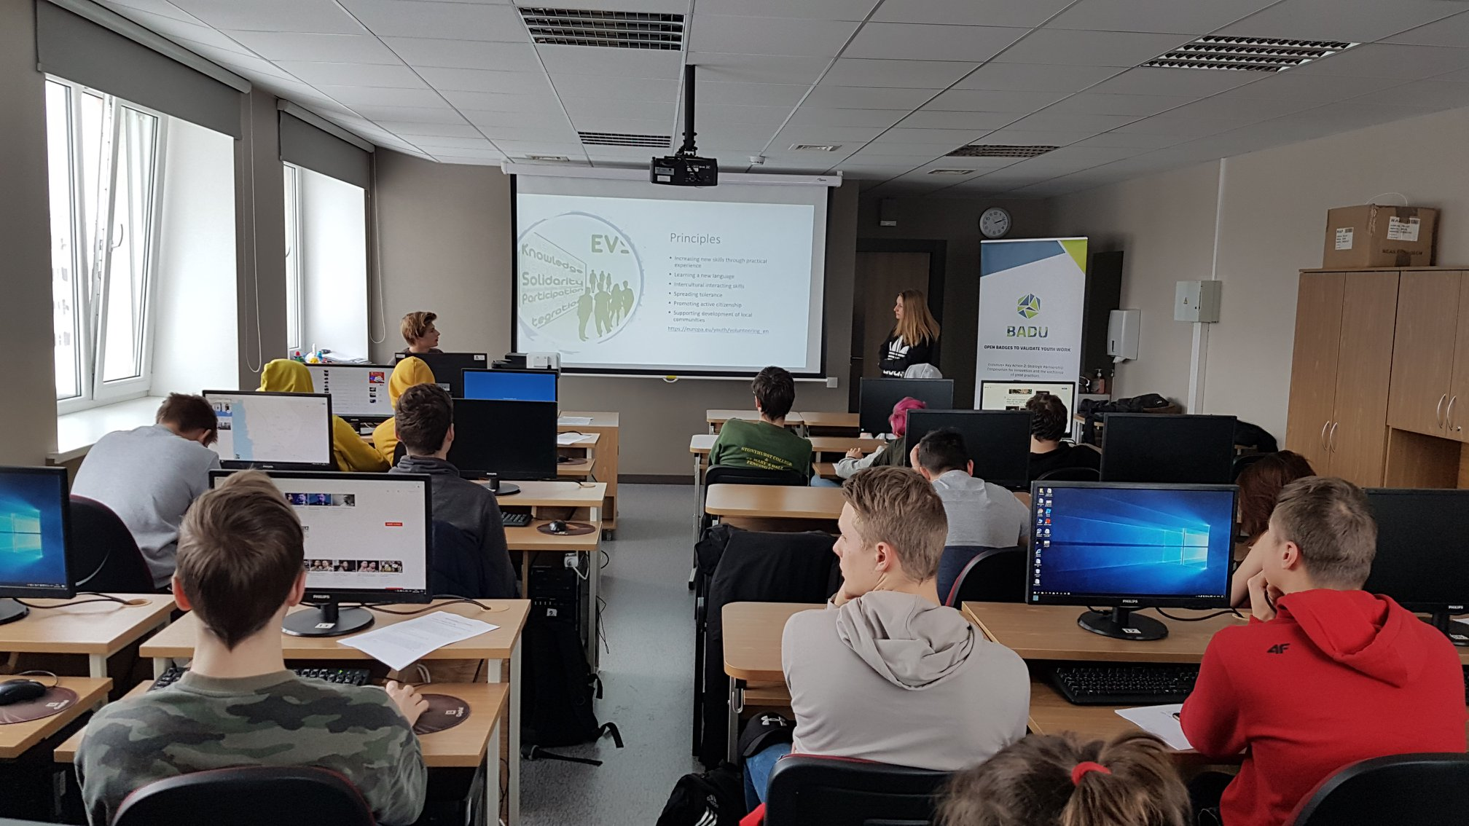

**4th WORKSHOP** - Society Integration office in Jelgava 27/03/2019

Workshop was organized only for Jelgava city youth workers to inform and train step by step how to use BADU open badges.

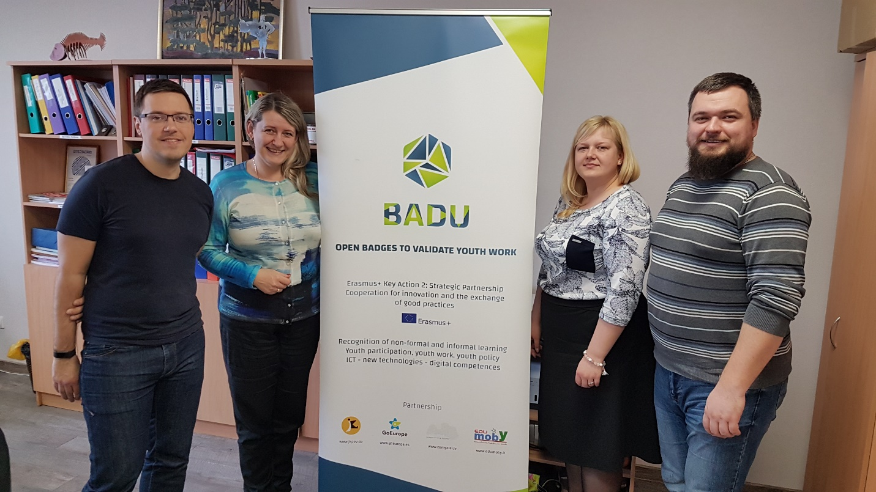

Jelgava city youth workers after the workshop.